Sunlife Coding challenge

Added Financial service picklist in Account- Industry (Picklist) and added some records

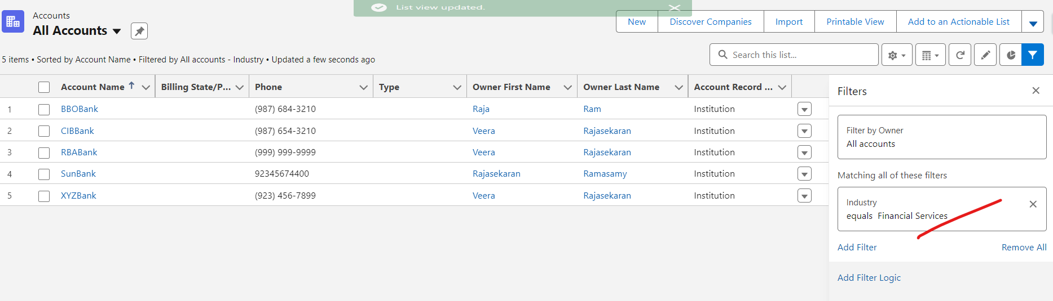

Created tab for datatable display

Title:Financial services account listing

Cloumns:Account Name, Owner Name,Phone,Website,Annual revenue

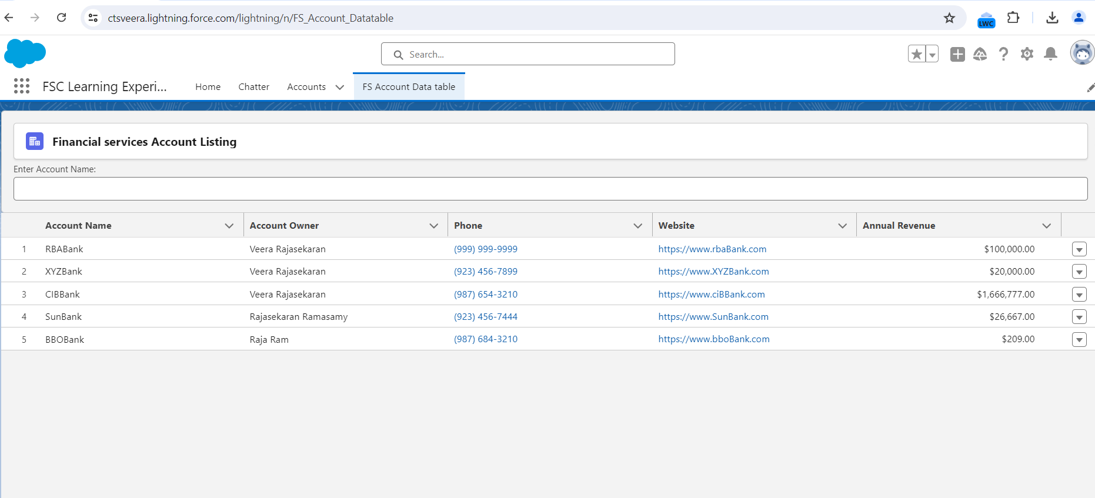

Sorting: Account name,Owner,Phone,Website, annual Revenue

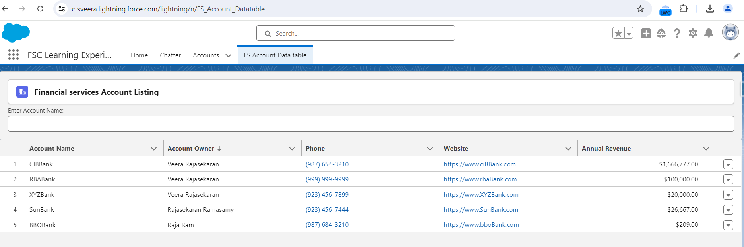

Filter :Using account Name

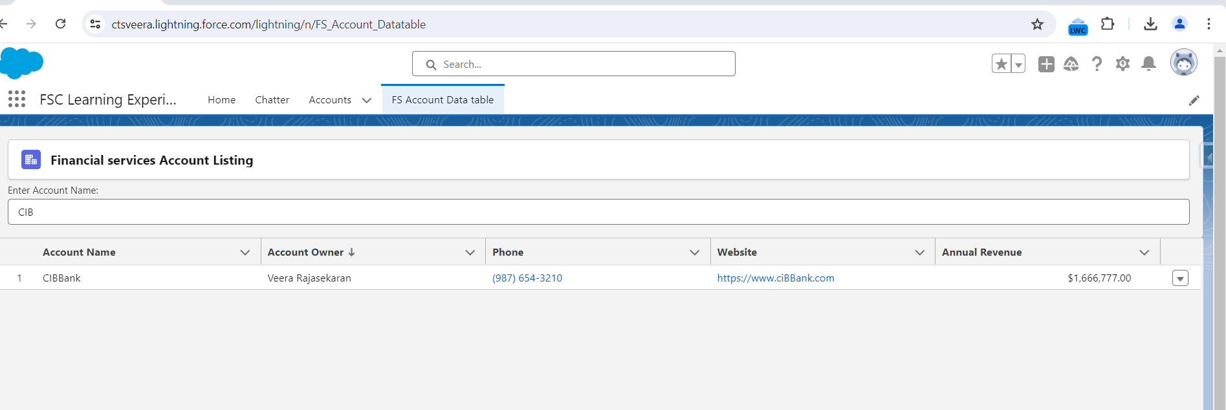

Inline Edit: Phone website,annual revenue columns

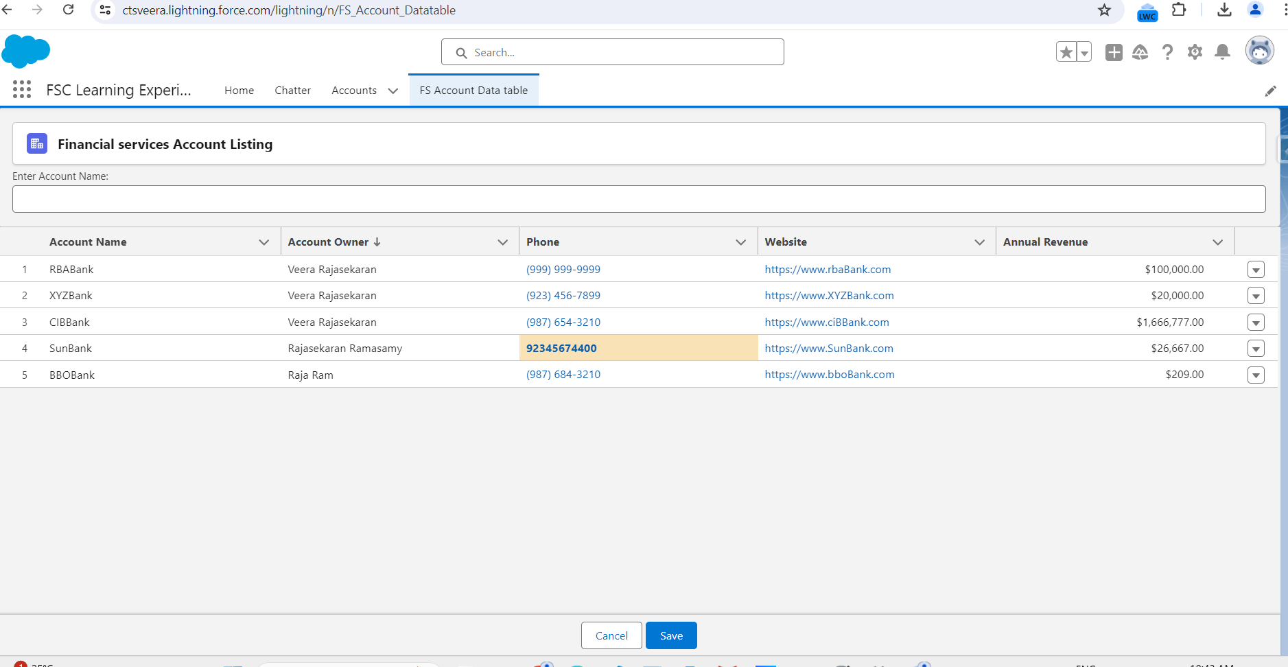

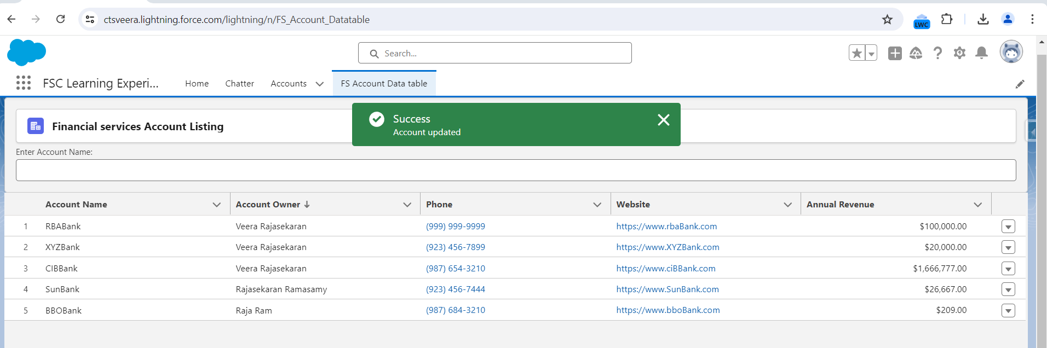Updated value

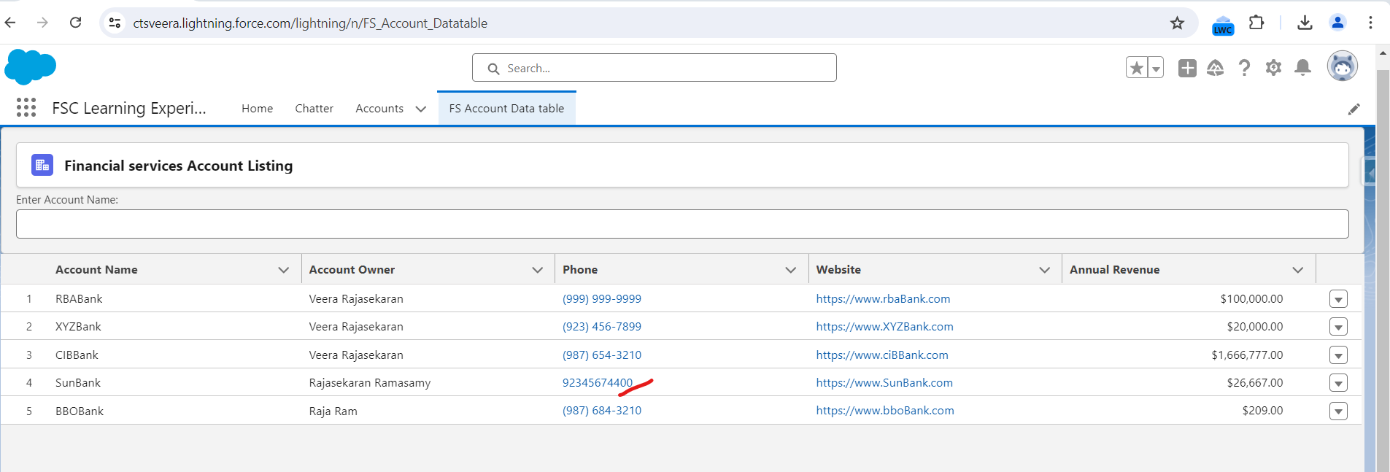

OnRowselect

Click on View account from dropdown

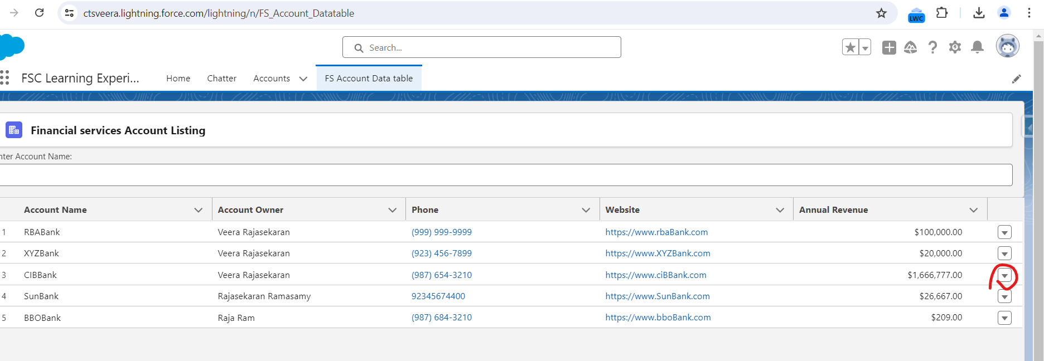

Opens account details in new tab

